**CIS 4375 User Manual**

Professor: Jose Martinez

Prepared By: TechSoft Systems Inc

Prepared For: Smile Architects

Project Sponsors: Dr. Truong Le

Date Submitted: 4/12/22

David Obitade

Randall Truong

Daniel Torres

Ricky Thomas

Joshua Wilson

Kevin Nguyen

Andy Luong

University of Houston

College of Technology

Spring 2022

Table of Contents

User Manual **3**

# 

# User Manual

A user manual is a guide that is intended to assist users with a product, service, or application. This user manual was created by a member of TechSoft Systems Inc and will be included when the system is given to the project sponsor. The purpose of this user manual is to illustrate and explain how to use the application using non-technical vocabulary. This manual will contain key functions and features of our application and the user will be able to understand, as well as use our application.

Website

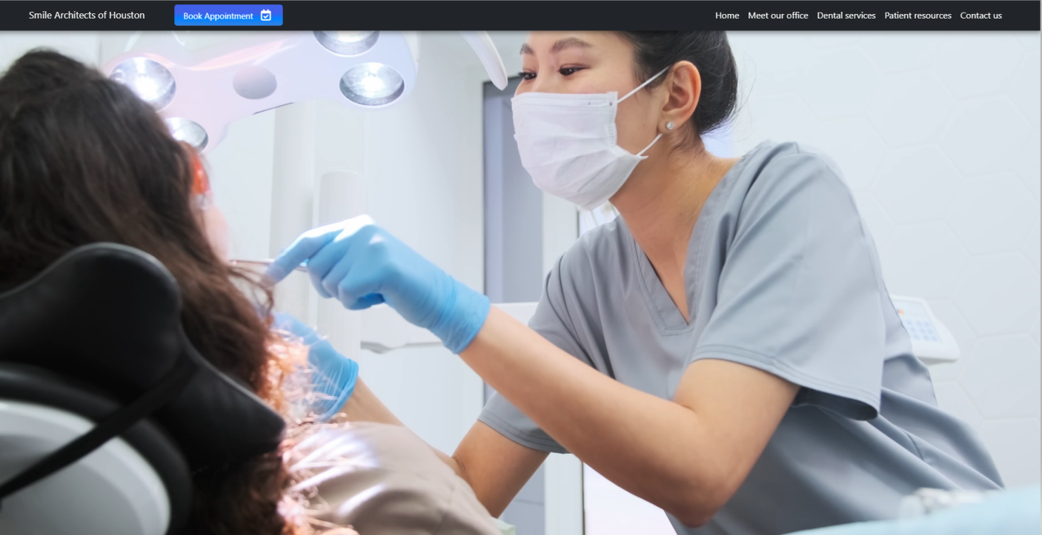

Book Appointment

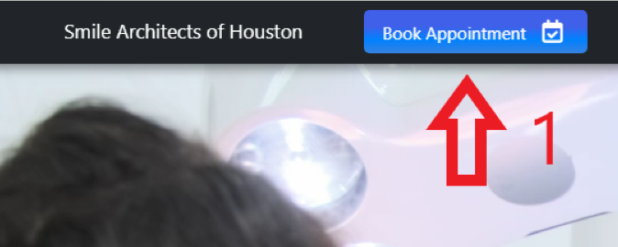

1. Book Appointment as patient

Enter Personal Information

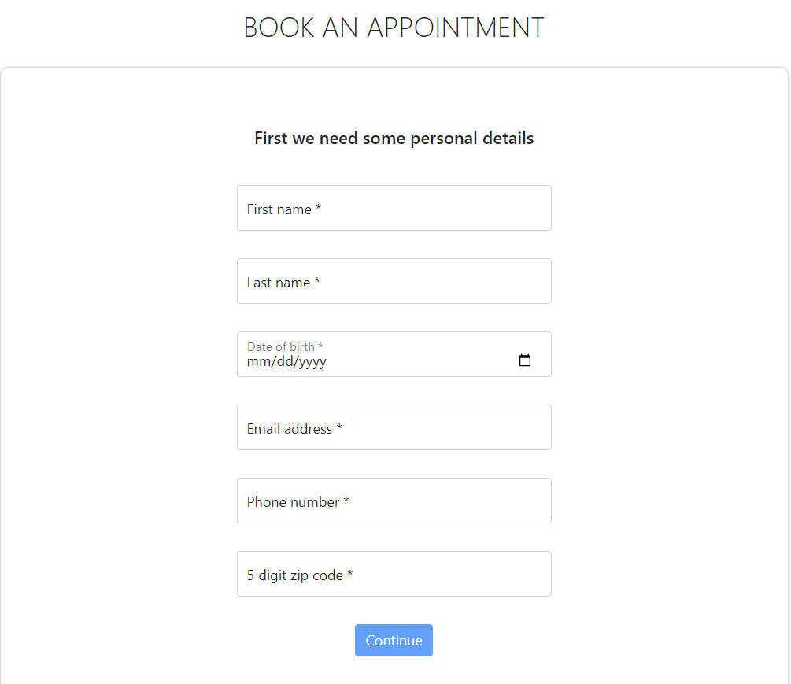

Enter Insurance Information 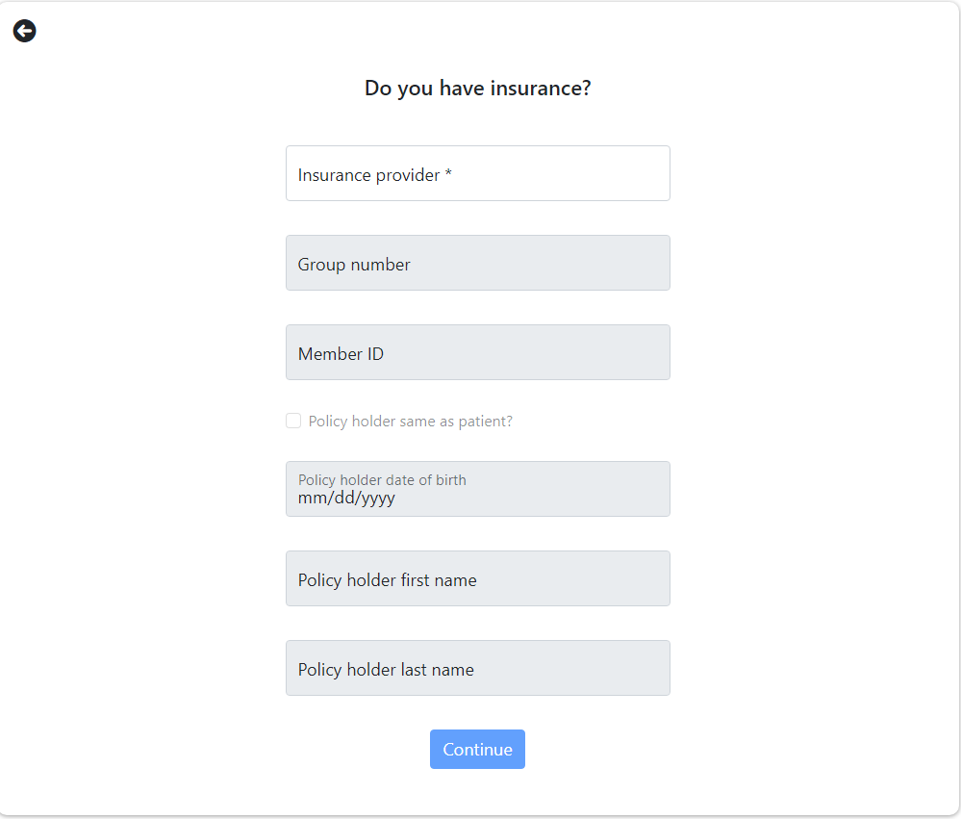

Select An Appointment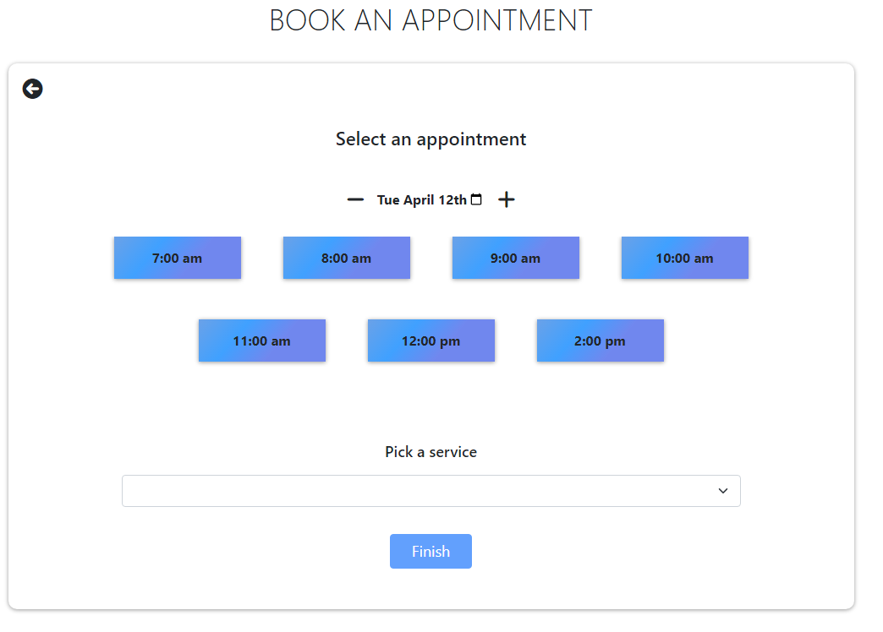

Bottom of Website

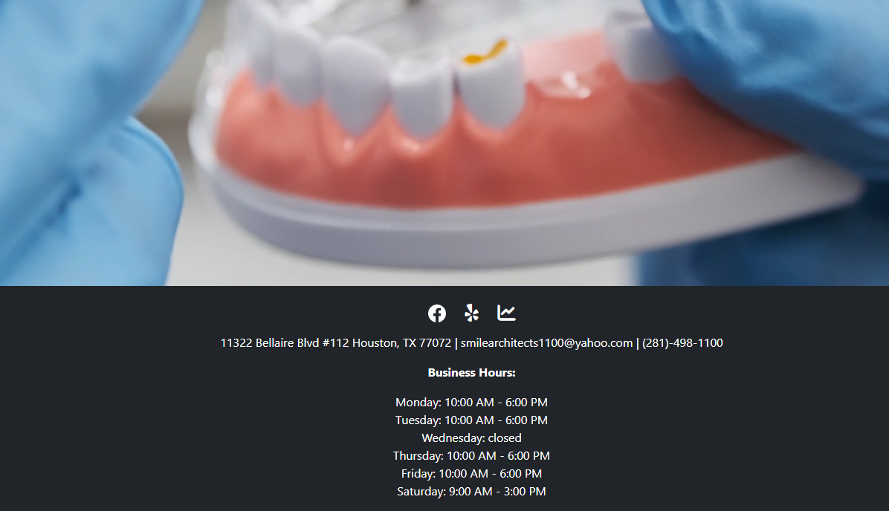

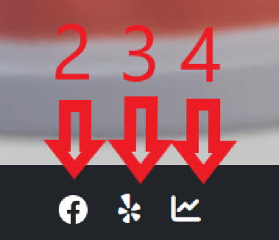

2. Facebook

3. Yelp Reviews

4. User Login

Employee Login

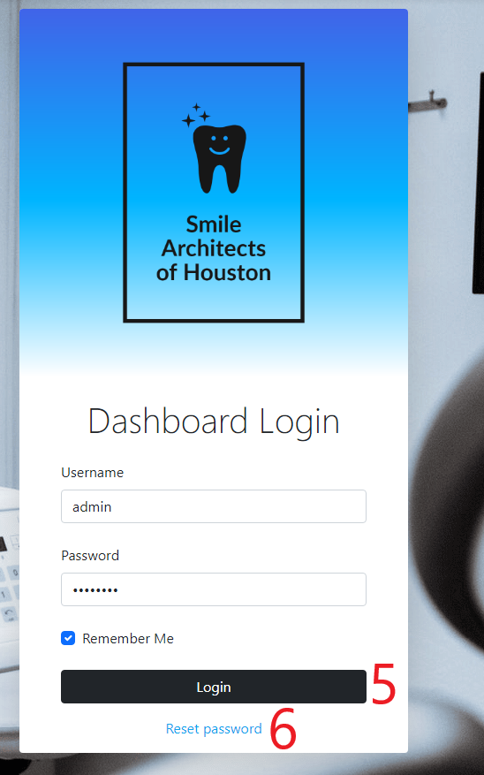

5. Login to dashboard

6. Employee reset password

Employee Dashboard

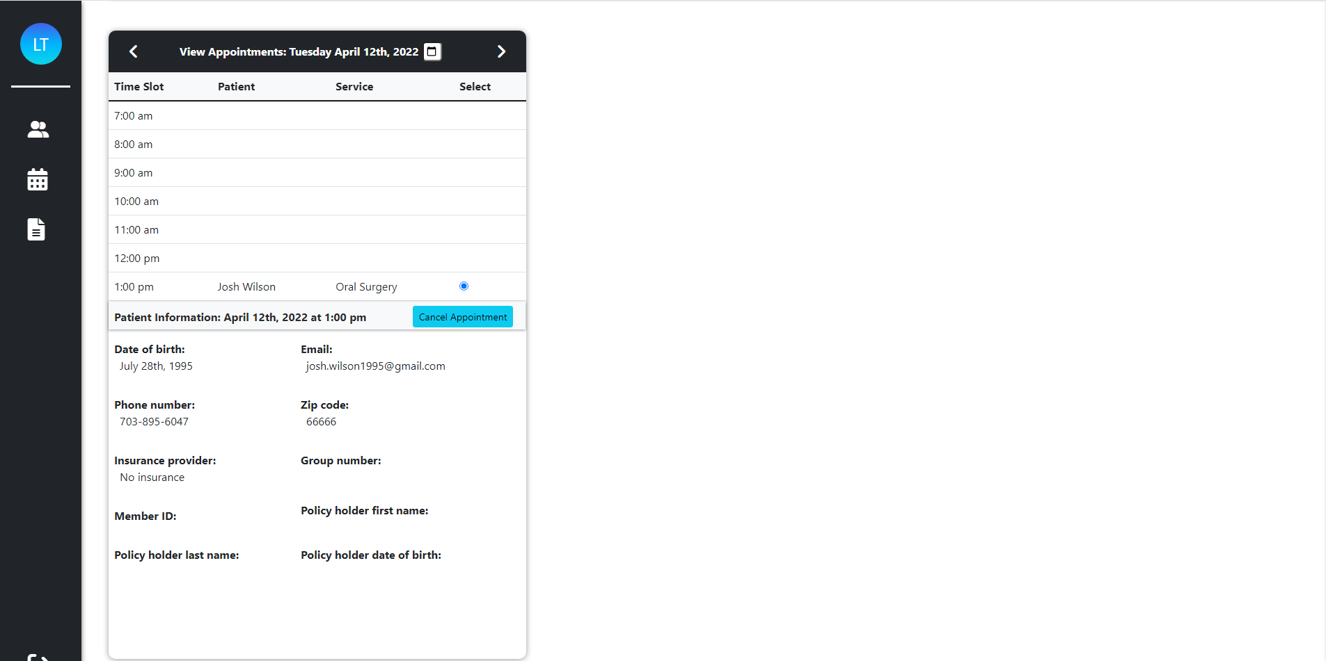

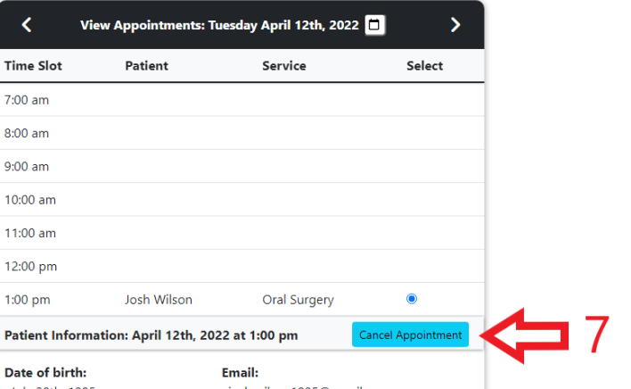

7. Cancel Patient Appointment

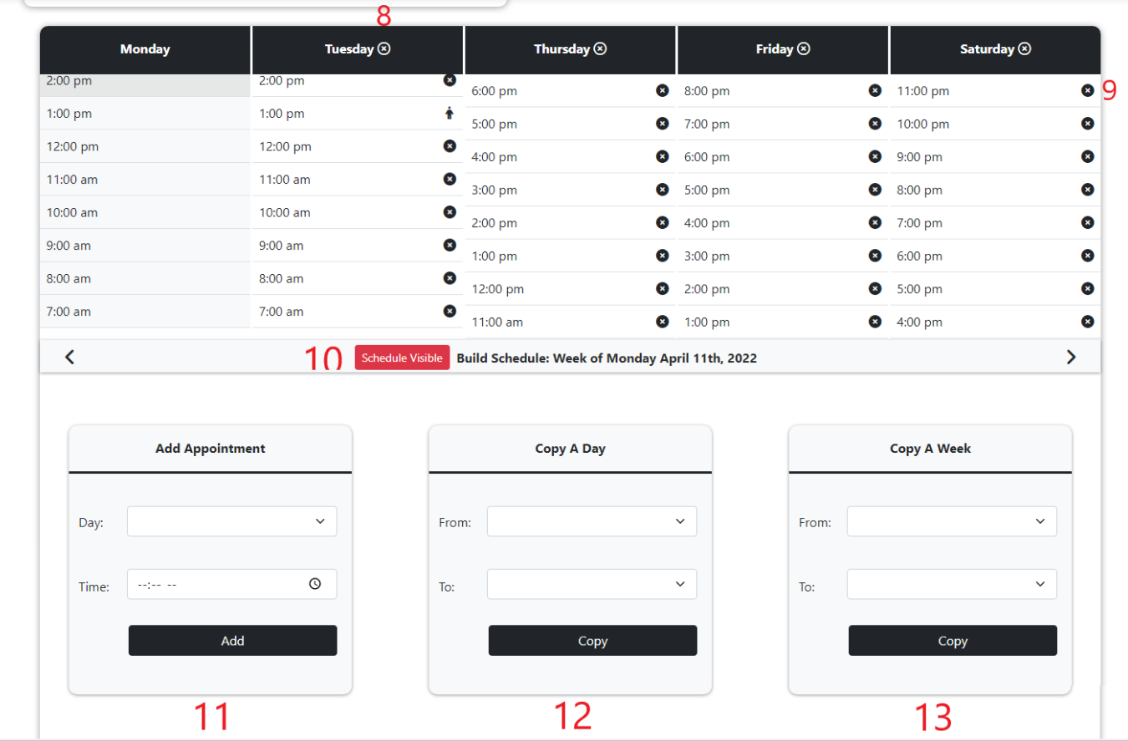

8. Delete a day of appointments

9. Delete an appointment time slot

10. Toggle to make schedule visible or invisible for patient to book appointments

11. Add appointment time slot

12. Copy a day of appointments from one day to another

13. Copy a week of appointments from one week to another

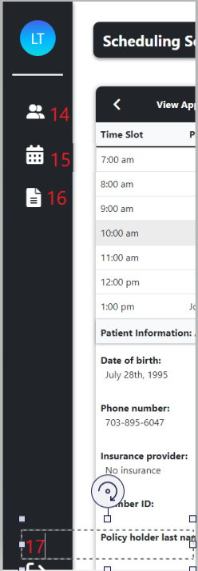

14. Employee Profiles

15. Scheduling Services

16. Analytics

17. Log out

Employee Profiles

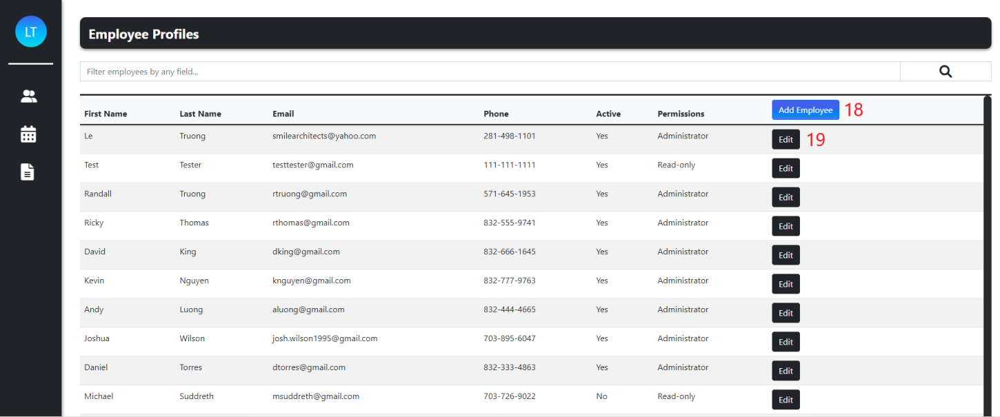

18. Add Employee

19. Edit Employee

Add Employee

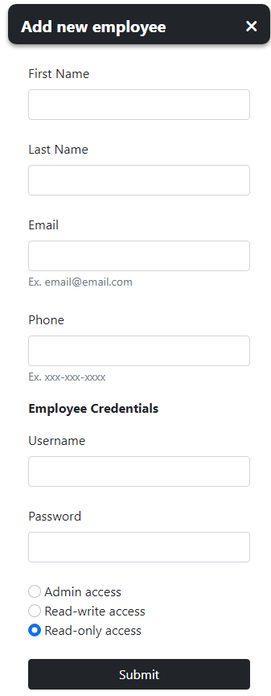

Edit Employee

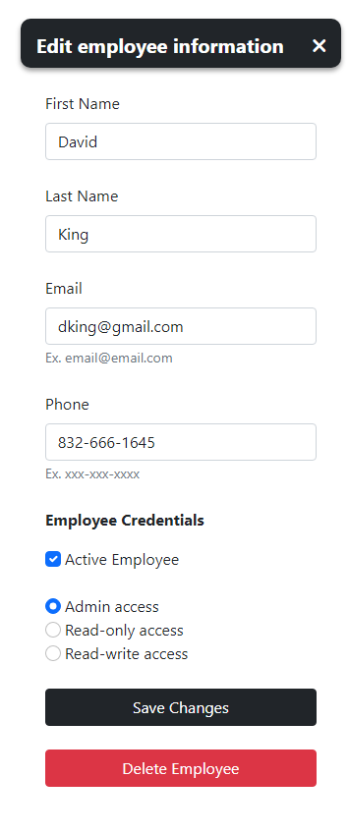

Analytics Page

